A Practical activity Report submitted

for Engineering Design Project-II (UTA-024) by

**Pulkit Arora 102103267**

**Submitted to**

**Dr. ...............................**



**DEPARTMENT OF ELECTRONICS AND COMMUNICATION ENGINEERING**

**THAPAR INSTITUTE OF ENGINEERING AND TECHNOLOGY, (A DEEMED TO BE UNIVERSITY), PATIALA, PUNJAB**

**INDIA**

**Jan-May 2023**

**Experiment: 1**

**Objective:**

1. To draw a schematic diagram of receiver to receive specified pulse width IR signals from gantries using CAD tool (Eagle).
2. To design a printed circuit board layout of receiver circuit using CAD tool (Eagle).

**Software Used:** Eagle Software

**Components Used:**

|  |  |  |  |
| --- | --- | --- | --- |
| **Sr. No.** | **Name of Component** | **Value** | **Specifications** |
| 1. | Resistor | 120k | Carbon resistor with 5% Tolerance |
| 2. | Resistor | 100k | Carbon resistor with 5% Tolerance |
| 3. | Resistor | 22k | Carbon resistor with 5% Tolerance |
| 4. | Resistor | 1k | Carbon resistor with 5% Tolerance |
| 5. | Capacitor | 100pF | Ceramic Capacitor |
| 6. | LM311N |  | Voltage Comparator |
| 7. | BPW41N |  | Pin Diode |
| 8. | 22-23-2031 |  | PCB Header |

**Theory:**

1. **Resistor:** Resistor are electronic components which do not allow charge to freely pass through them. It is used to limit or regulate the flow of current in electric circuits.

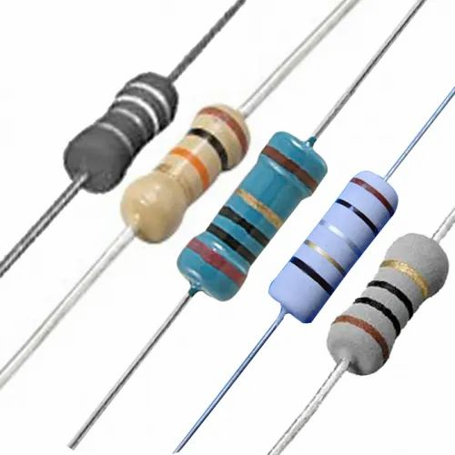

**Fig 1.1:** Various resistors

1. **Capacitor:** A capacitor is a device that stores electrical energy in an electric field by virtue of accumulating electric charges on two close surfaces insulated from each other. It is a passive electronic component with two terminals.

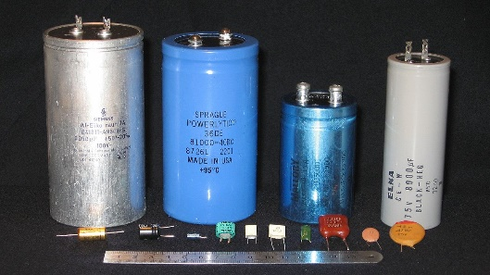

**Fig 1.2:** Various capacitors

1. **LM311N:** The LM311N is a single comparator. In other words, it is internally composed of one comparator. The LM311N compares these voltage inputs and determines which value is larger.

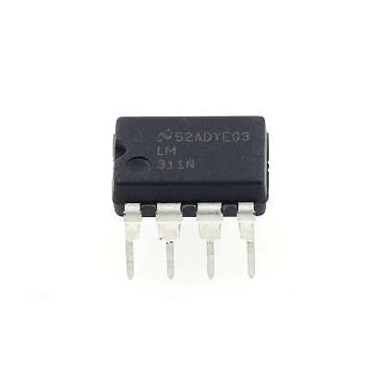

**Fig 1.3:** LM311N

1. **BPW41N:** This is a Schottky diode made of silicon carbide. Schottky diodes are used for their low turn-on voltage, fast recovery time and low-loss energy at higher frequencies. These characteristics make Schottky diodes capable of rectifying a current by facilitating a quick transition from conducting to blocking state.

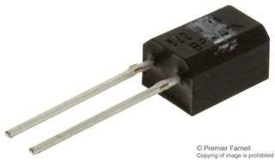

**Fig 1.4:** MBD701

1. **22-23-2031:** 22-23-2031 is a 2.54 mm pitch wire to board connection which are the header pins that are used for connecting 2 wires seamlessly.

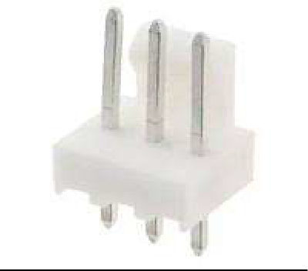

**Fig 1.5:** 22-23-2031

**Schematic Diagram:**

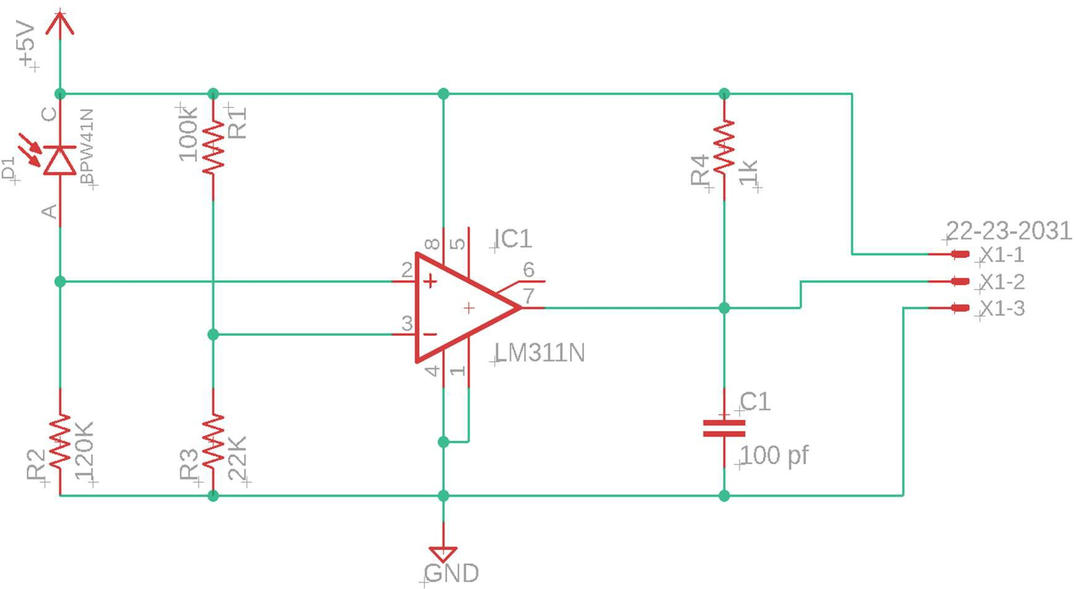

**Printed Circuit Board Layout:**

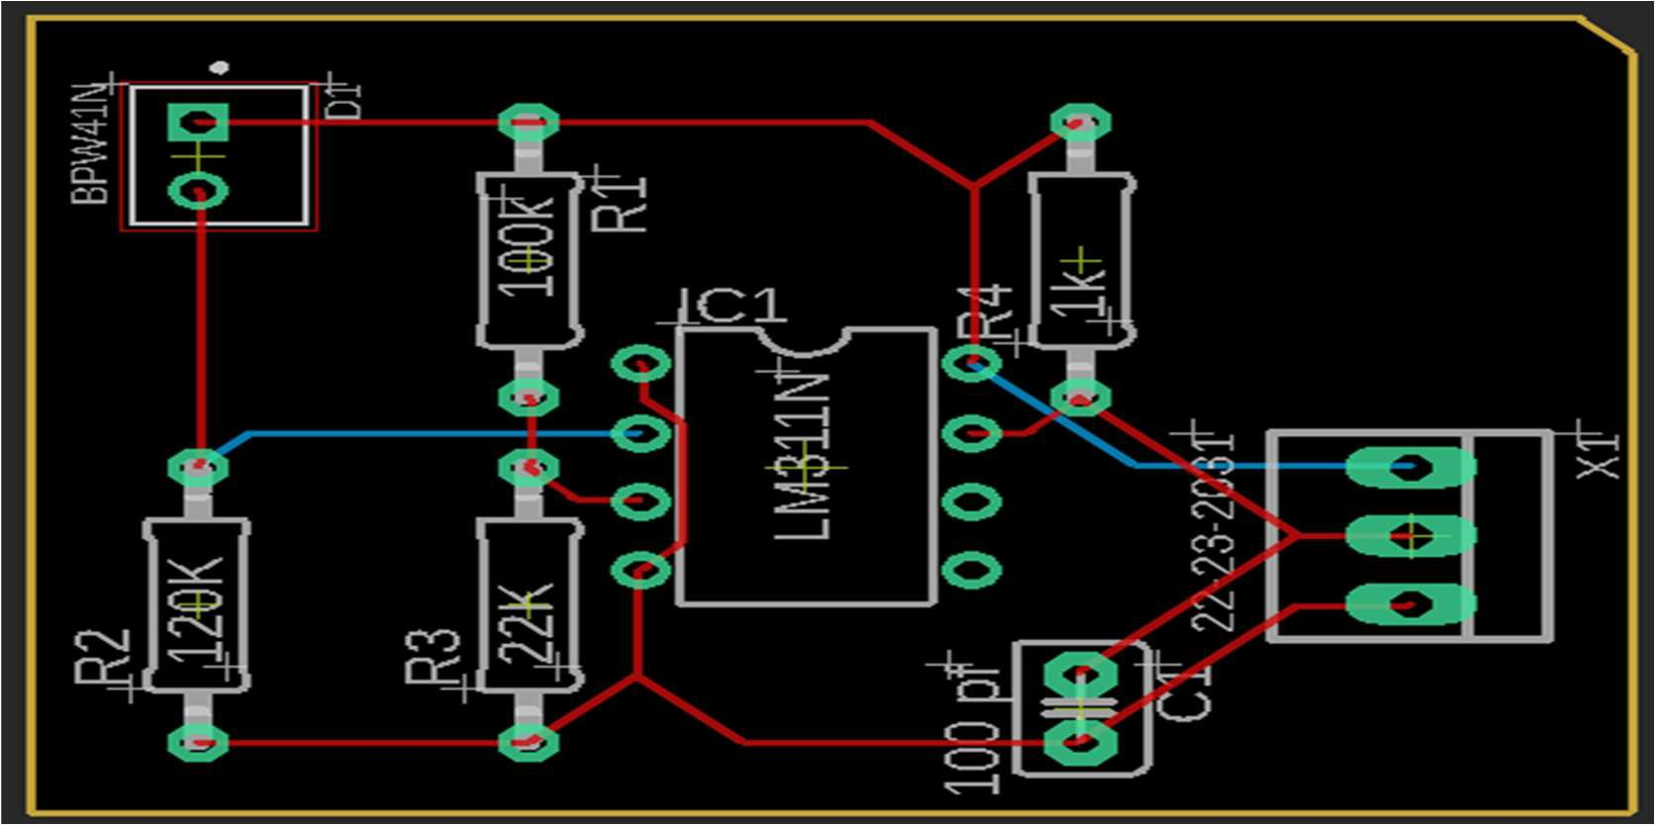

**Discussion:**

In this experiment, we successfully made a schematic diagram and a PCB layout of the receiver circuit based on the pulse width modulation (PWM) using CAD tools (Eagle Software).

We learned the importance of a receiver module for the project “Buggy”. With the receiver circuit placed on the buggy, whenever the buggy crosses a gantry; which has a transmitter; it receives a signal from the gantry and sends it to the Schottky diode on the receiver which works as a switch. If the receiver a signal it automatically changes to a short circuit state and open the circuit when it doesn’t.

**Signature of Faculty member**